2/22/2021

Nadir Hussain

023-18-0025

Computer Networks

Lab-0

**Lab Objectives:**

**Part B**

**Network Interface**

1. Know your communication interface

Unplug the RJ 45 or Ethernet cable or UTP

re plug the connector and observe the connectivity process

find following

host name of your PC

# of interfaces (virtual and physical)

l and how much data speed does it support

IP address of your PC

DNS primary suffix

DNS server : how many? which is primary? which is public and which is private

Lets ping our neighbors

ping an IP

ping an hostname

ping with -n

ping with -t

lets use name server (dns) to know IP address of www.iba-suk.edu.pk

lets trace www.google.com

**Host name of your PC**



**OR**

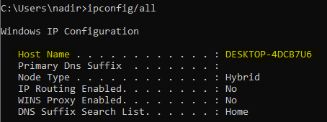

Hostname is **DESKTOP-4DCB7U6**

**Number of interfaces(Virtual and Physical)**



**From command line:**



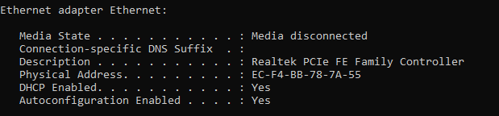

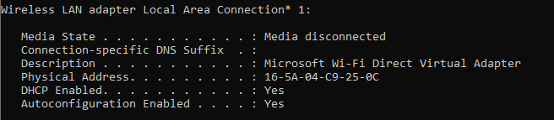

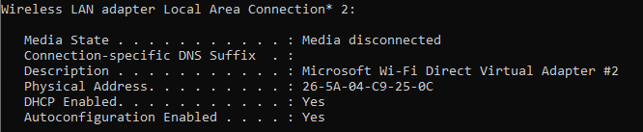

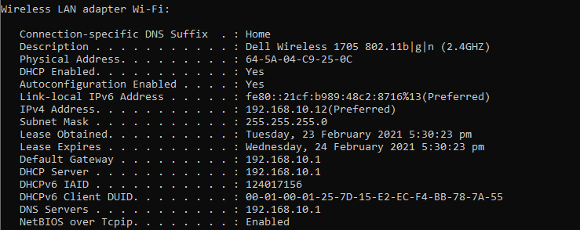

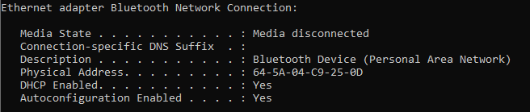

**How much data speed each interface supports:**

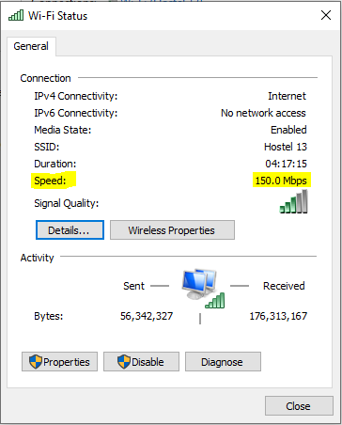

**Or For each Interface we can find from description**

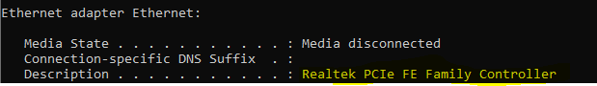

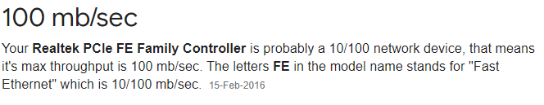

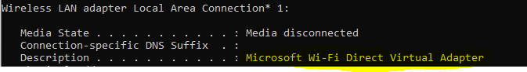



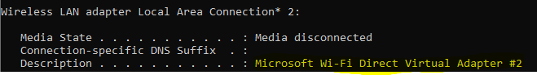



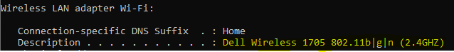

It supports **35mbps** of speed

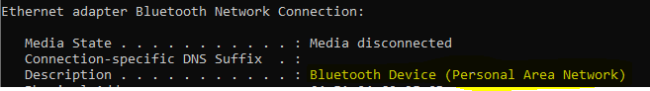

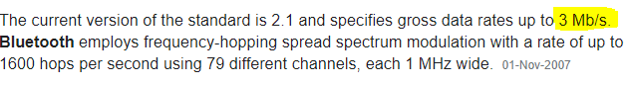

**IP address of your PC**

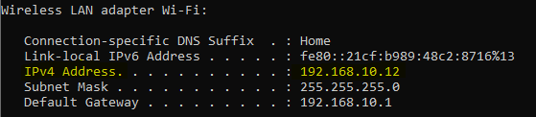

IP address is **192.168.10.12**

**DNS Primary suffix**

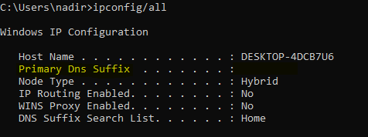

There is **no** primary DNS suffix

**DNS Servers:**

How many? Which is primary and which is secondary?

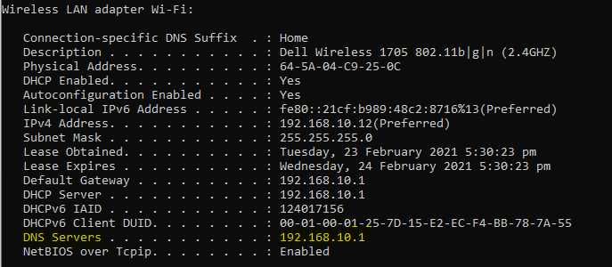

**There is only 1 DNS Server at this network. Which is only primary DNS. There is no secondary DNS server.**

It’s a private DNS, there is no public DNS in this list.

**Lets ping our neighbors**

**Ping an IP**

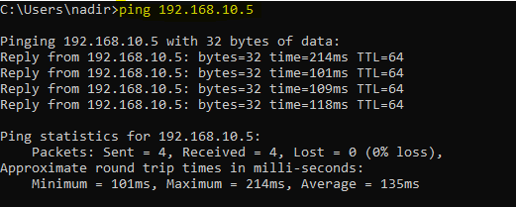

**Ping hostname**

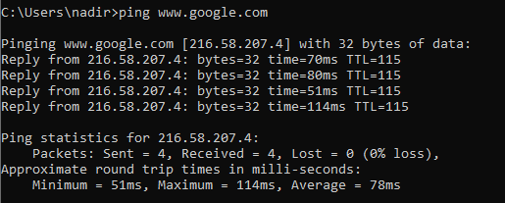

**Ping with -n**

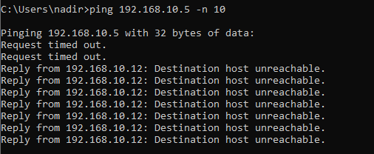

**Host was unreachable, let try with google server**

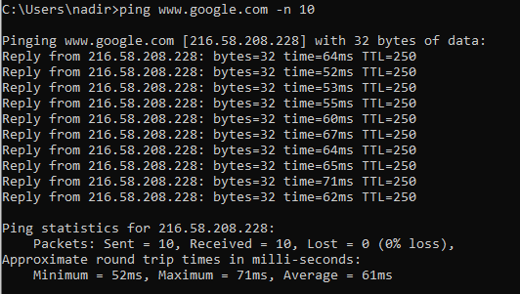

**Ping with -t**

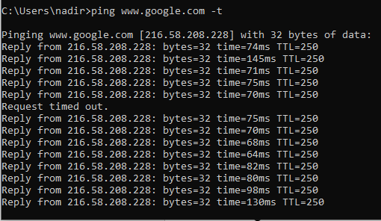

It tells whether host is listening or not.

**Use name server to know IP address of IBA**

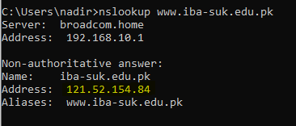

IP address of [www.iba-suk.edu.pk](http://www.iba-suk.edu.pk) is **121.52.154.84**

**Use name server to know IP address of Google server**

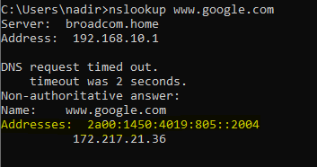

It uses IPv6

**tracert command**

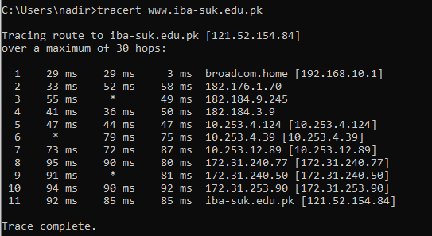

**Using Wireshark to capture surfing details of**

[**www.iba-suk.edu.pk**](http://www.iba-suk.edu.pk)

**Initially when my PC send Http request**

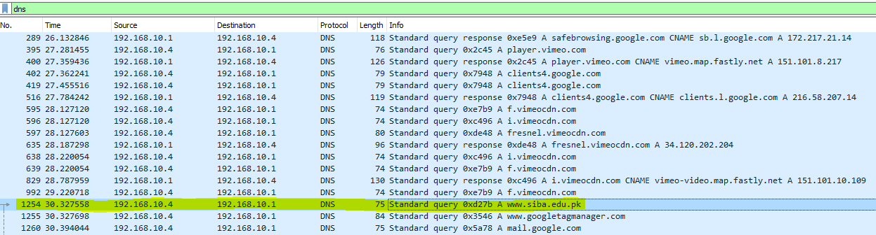

The request was received by DNS server having IP address **192.168.10.1**

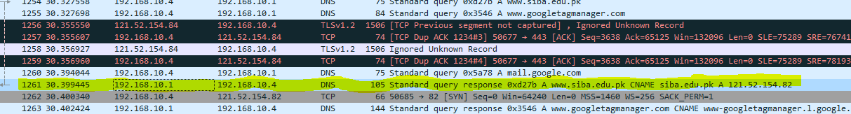

The DNS server responded at IP address **192.168.10.4**

Then the server with IP address **121.52.154.82** was requested to respond the client with IP address **192.168.10.4**



A TCP connection was provided by server having IP **121.52.154.82** to client having IP **192.168.10.4** which is my PC

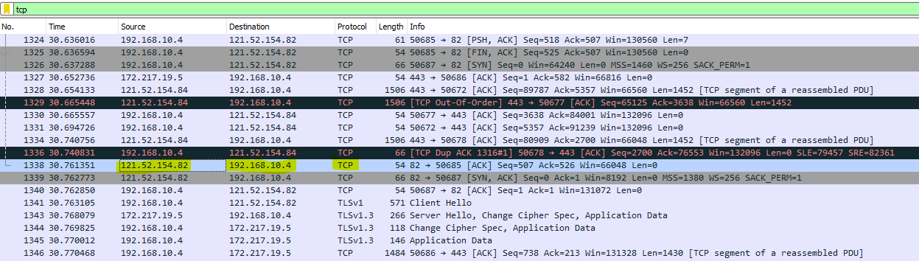

Then client says hello to server i.e source is **192.168.10.4** and destination is **121.52.154.82**

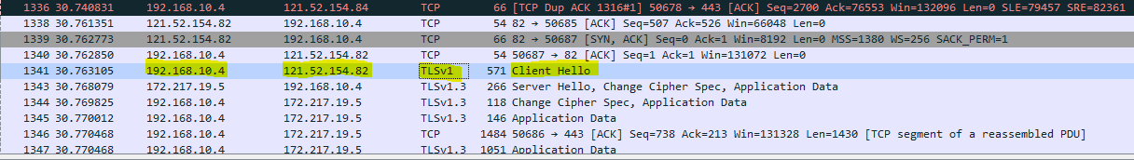

Then server responded to client with Server Hello Message

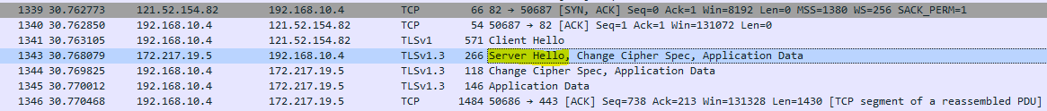

Now data is being shared throughout until website is opened in the browser.

**The End**